**EXERCISE.NO:8**

**DATE:23/11/2020**

**AIM:**

*To write a python program to get a list of numbers of list and create a list of tuples having first element as the number and second element as the cube of the number , next the line of tuples should be sorted in increasing order by the last element in each tuple from a given list of non-empty tuples.*

**PROGRAM:**

*n=int(input())*

*lst=[]*

*for i in range(n):*

*a=int(input())*

*lst.append(a)*

*r=[(j,pow(j,3))for j in lst]*

*print(r)*

*def first(n):*

*return n[0]*

*r.sort(key=first)*

*print(r)*

**LINK:**

[*http://103.53.53.18/mod/vpl/forms/edit.php?id=317&userid=1783#*](http://103.53.53.18/mod/vpl/forms/edit.php?id=317&userid=1783#)

**OUTPUT:**

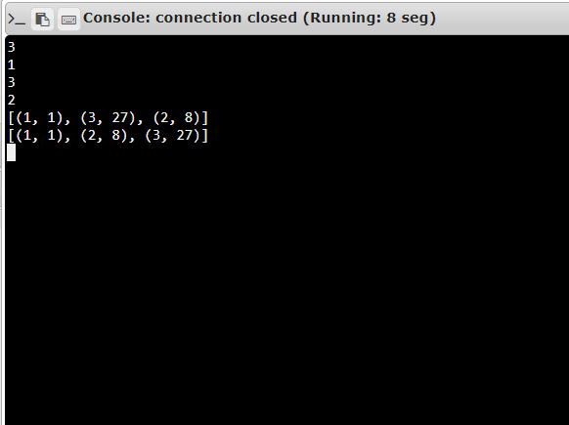

**RESULT:**

*The output for the program is successfully executed and verified.*